DO₃SE User Guide
Stockholm Environment Institute

Introduction
This document describes the user interface to the DO₃SE model and how to use it to configure and run the model. It does not cover the DO₃SE model itself in any significant depth - the accompanying “Documentation of DO₃SE model” covers the model.
The user interface is designed with a simple workflow in mind, by first configuring the model and then running it on an input data file to create a result set. Each result set is displayed in a new window, and that window allows you to view the data and save it to a file.

Main window
Upon running the program, the “main window” appears, consisting of several tabs and a menu. The first tab is a short introduction to the DO₃SE model and interface – reading this introduction is recommended before using the model.
The other tabs allow you to configure how the input data will be read and various aspects of the model. Each tab has a “presets” bar at the top – this is for saving and loading parameters for a tab and is explained later, in the “Presets” section.
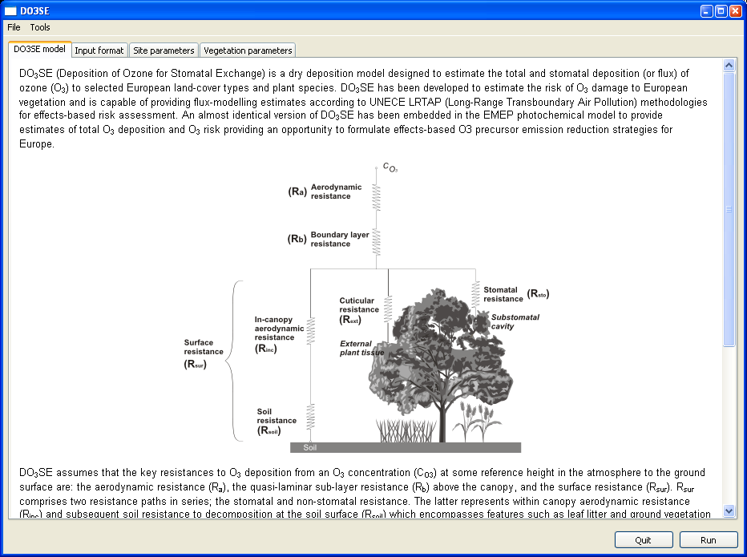

The menu
The “File” part of the menu contains items for exiting the application and running the model. Clicking “Run” will open a dialog for selecting an input data file. The “Run Recent” submenu provides a shortcut to running the model with recently used input files.
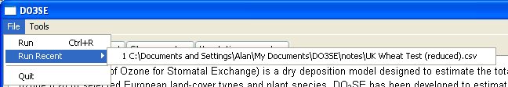
The “Tools” part of the menu contains items for saving and loading settings. The settings consist of the input format defined on the “Input format” tab and all parameters defined on the “Site parameters” and “Vegetation parameters” tabs. Clicking “Dump settings” will prompt for a file to save the current settings to. A settings file created in this way can then be loaded by clicking “Load settings”. If given a settings file and related input data file, another user should be able to exactly reproduce your results from running the model.
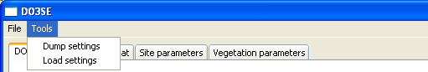

The “Input format” tab
The “Input format” tab allows you to specify the format the input data file is in. This consists of two things: the fields that are present (and their ordering), and the number of rows to ignore from the beginning of the file. This last parameter allows headers to be present in the data while not affecting the operation of the model.
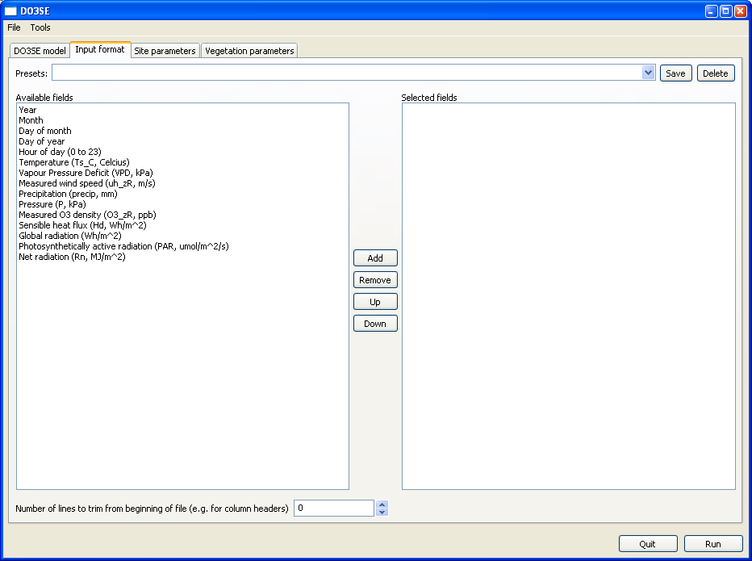

The “Site parameters” tab
The “Site parameters” tab allows you to specify values for parameters which are properties of the location rather than of the vegetation itself such as elevation and heights at which measurements are taken.
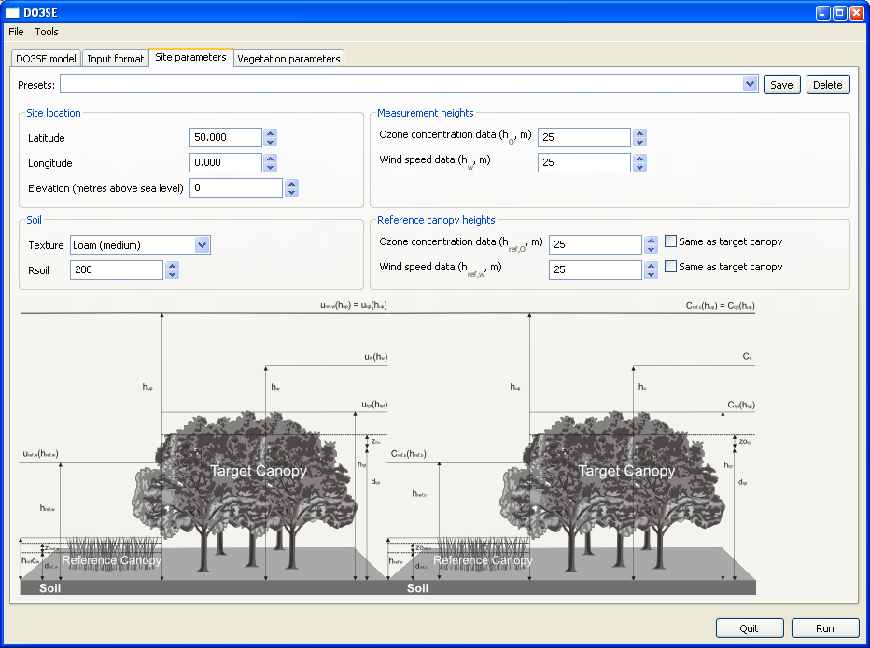

The “Vegetation parameters” tab
The “Vegetation parameters” tab allows you to specify values for vegetation-specific parameters. Since these make up the majority of the parameters, they are further grouped into two tabs.
The “Characteristics and environment” tab contains properties of the vegetation (such as root depth and canopy height) and its response to environmental factors (such as temperature and humidity).
[INSERT IMAGE HERE]
The “Phenology” tab defines the functions for Leaf Area Index, F_{phen} and leaf f_{phen}.
[INSERT IMAGE HERE]

Results window

The “Data” tab
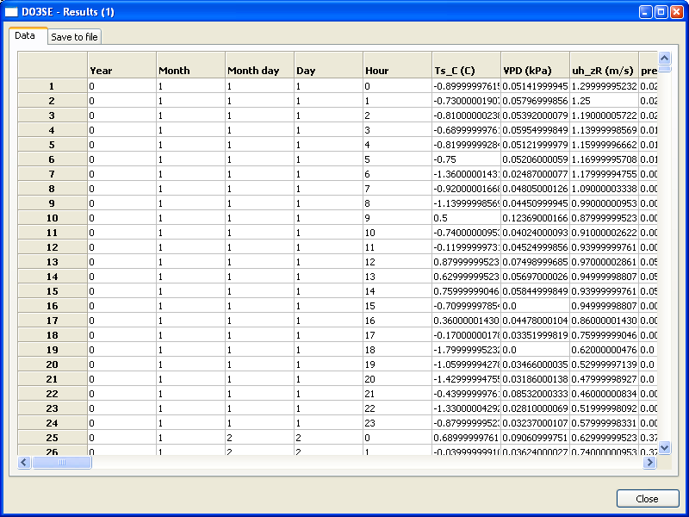

The “Save to file” tab
